**Exercise 3**

**1) Open IDE**

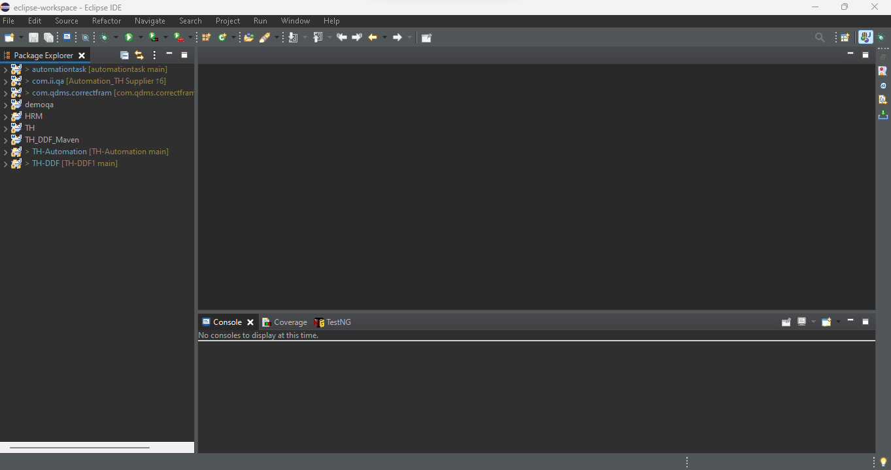

**2) Create a new Java project**

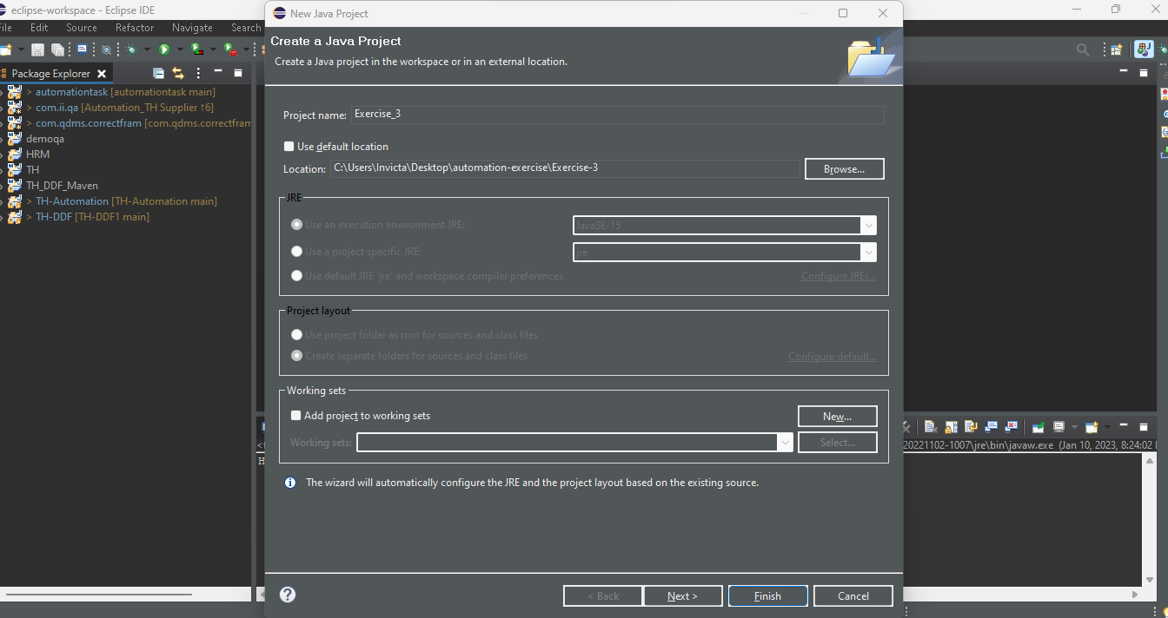

**3) Type the same program you created in Exercise 2 and execute it through Eclipse/ IntelliJ IDEA**

